OUTPUT
TASK 1: TOTAL EXPENSES
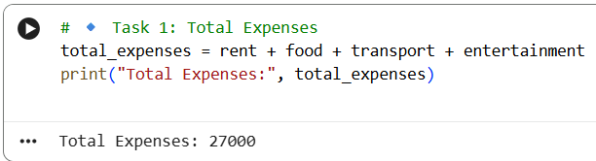
TASK 2 : SAVINGS CALCULATION
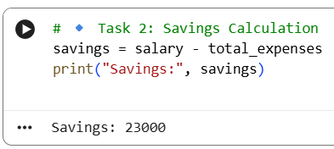
TASK 3: EXPENSE COMPARISION
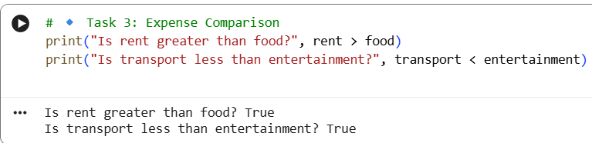
TASK 4: FINANCIAL CONDITION CHECK
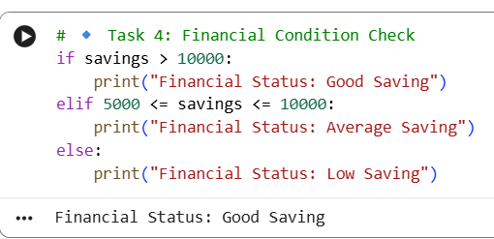
TASK 5: BONUS UPDATE (10% SALARY INCREASE)
